**Sustainable Hybrid EV Charging Station**

**Introduction:**

An EV charging station, also called an **EV charger** or **electric vehicle supply equipment** (**EVSE**), is a piece of equipment that supplies electric power for charging plug-in electric vehicles (including hybrids, neighbourhood electric vehicles, trucks, buses and others).The EV charging station is written in C language with proper testing cases and make file.

**Research:**

One of the most important considerations with this project was to ensure EV charging station diversity in location, organization and facility type. With a growing number of local and regional carbon-reduction policies, EV charging stations may be able to benefit from the value of carbon emissions offset by their stations

**Objectives:**

* Clean Air Commitment
* Lower cost of driving
* EVs pave the way to other forms of clean transportation
* Electric vehicles support environmental justice
* EV charging increases property value

**Features:**

* Helps in charging multiple EVs at a time.
* EV Charging Station with 5 modular charging ports – 3 Scooters and 2 Cars at a time.
* Each charging port provides power output as needed by the vehicle.
* System is adaptable to all seasons.
* Charges EV considering the required safety protocols and monitors overcharging of EV as well.

**High Level Requirements:**

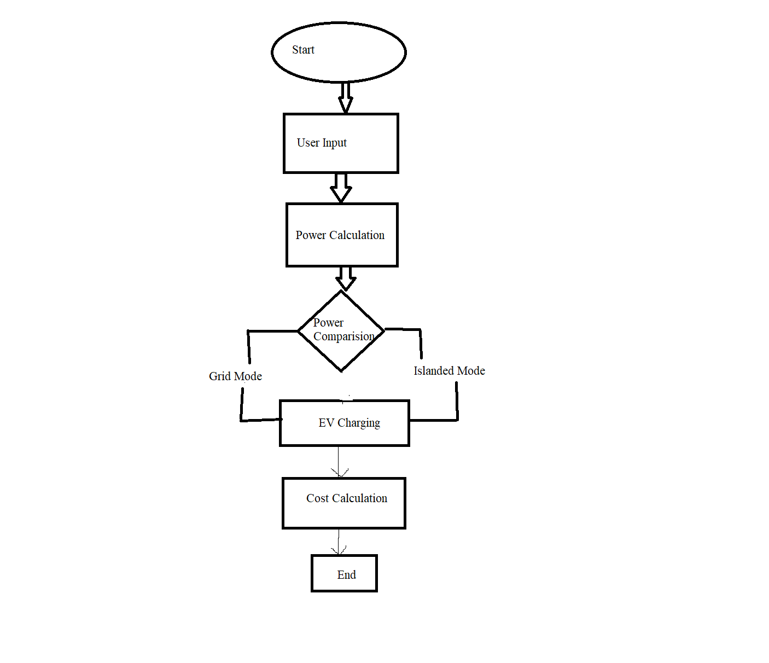

* Getting input from PV
* Check for power consumption of the EV – if more is required, grid can be used.
* Cost calculation for charging EV
* Profit calculation for plant owner
* Net metering (feedback to grid)
* *Take power from both solar and grid*

**Low Level Requirements:**

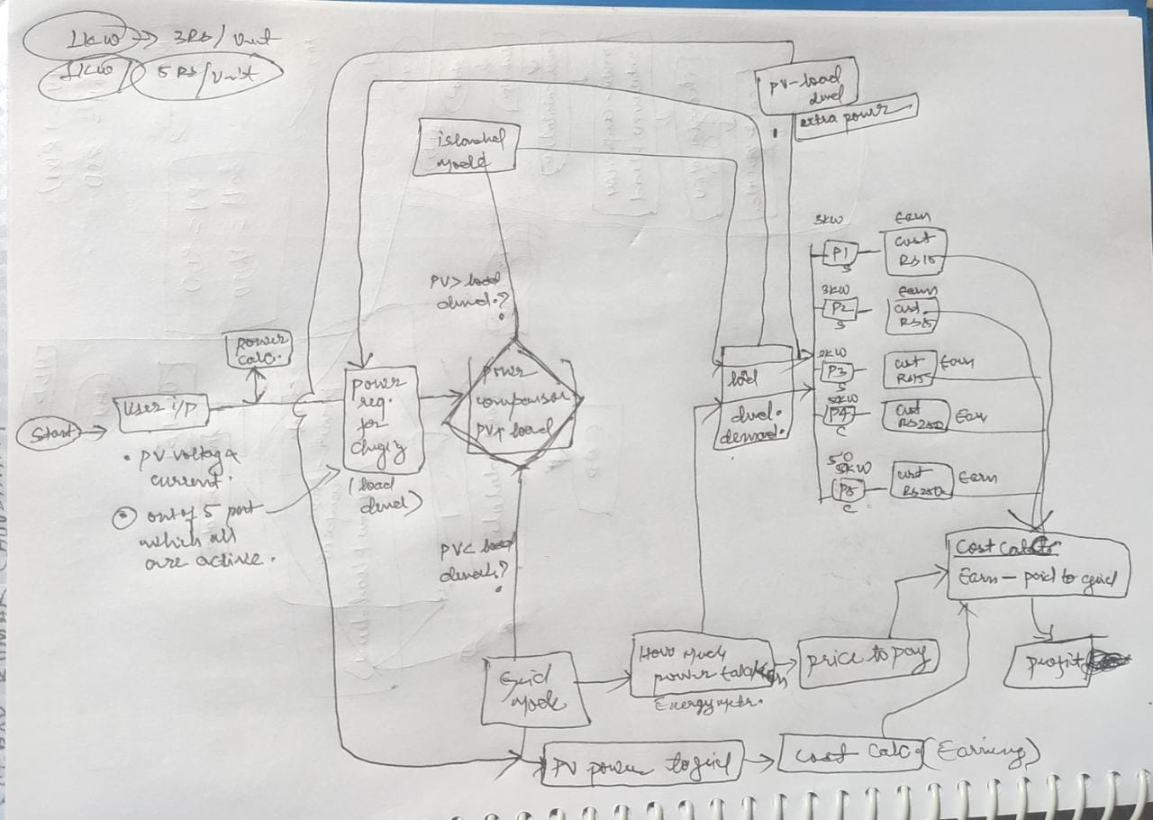

* Calculation of PV Power
* Calculation of load demand
* Checking power condition (check for mode of operation – islanded/grid)
  + Grid - PV Power < Load ; Take power from grid & Net Metering
  + Islanded - PV Power >= Load ; Directly power the station & send surplus to grid
* Calculation of EV Power Consumption
* Calculation of power used in net metering
* For charging port – 3 scooters, 2 cars ( 3x3 + 2x50 = 109)kWh -> Max power when all ports are being used. Check whether power is within constraints for each vehicle (for vehicle safety)
  + Price paid to grid per unit – Rs 3
  + Cost to Customer per unit – Rs 5
* Scooter – 3kWh, Car – 50kWh
* What is maximum amount of power being produced by PV and how many vehicles can be charged in a day? (Assuming PV Max Power = 120kWh)

**SWOT:**

*Strength* – Use of sustainable energy, profitable, decreases pollution, adaptable.

*Weakness* – Limited charging ports, high installation cost, different manufacturers have different charging ports, PV cannot be used in case of unfavourable weather conditions, grid shortage

*Opportunities* – Installation near establishments with limited space (since they do not possess enough available space to install charging ports), long distance travellers require charging points for their vehicles at different intervals during their journey, ports can be increased, wind energy can also be leveraged.

*Threats* – Development of a universal charging cord for different kinds of EVs in the future

**4W 1H:**

Who – Anyone who wants to charge their EVs

What – Sustainable Hybrid EV Charging System

When – Can be used in all seasons, in any weather condition

Where – Public spaces, Petrol Pumps, National and State Highways

How – Creating a profitable, sustainable energy solution for charging EVs